PROJECT - RUPEE TRACK



Student Name : ANUBHA SHARMA
Registration No. : 25BCE11044
Subject : CSE1021 INTRODUCTION TO PROBLEM SOLVING
College : Vellore Institute of Technology , BHOPAL
Year : 2025
Submitted To: MOSES DIAN
Slot: C11+C12+C13

Introduction

This project is a Python-based Expense Tracking System designed to help users maintain a record of their day-to-day expenditures. The system uses the Pandas library to process tabular data and supports recording expenses, converting date formats, categorizing transaction types, and extracting monthly spending patterns.
It is simple, offline, and efficient—ideal for basic financial management and learning data processing concepts in Python.

Problem Statement
Many individuals struggle to track everyday expenses due to manual record-keeping, inconsistent logs, and lack of simple tools. Existing apps may be complex, require internet connectivity, or offer no customization for INR-based expenses.
Thus, there is a need for a lightweight, user-friendly Python program that:
- Stores day-to-day expenses
- Categorizes entries automatically
- Extracts monthly spending insights
- Helps users analyze where their money is going.
- This project solves the problem by offering an easy, offline, and customizable tracking system.

Functional Requirements
1. Data Module
- Create sample expense data (CSV)
- Load expense data from a CSV file
- Convert date strings into date-time format
- Extract month from each date
2. Categorization Module
- Identify expense type from description(e.g., groceries, fuel, dining, café)
3. Processing Module
- Clean and organize the dataset
- Handle missing files safely
- Return a structured Data Frame for further analysis

Non-Functional Requirements

1. Usability: Simple function-based structure; easy to run.
2. Reliability: Handles missing CSV files without crashing.
3. Maintainability: Clean modular code for future enhancements.
4. Performance: Processes data instantly using Pandas.

5. Extensibility: Can be expanded to include charts, reports, GUI
, etc.

System Architecture

Layers:
1. User Interface: Python script / console
2. Processing Layer: Data loading, categorization, month extraction
3. Storage Layer: CSV file (sample_expenses.csv)
4. Analysis Layer: Data Frame operations (future—graphs, summaries).

Flow:
User → Python Program → Load CSV → Process Data → Categorize → Output Structured Data

Design Diagrams

Use Case
- Add expense data
- Categorize expense
- Generate monthly summary
- Save/read CSV

Workflow
Start → Load/Create Data → Process Data → Categorize Expense → Display Results → End

Component Diagram
- create_sample_data()
- load_and_process_data()
- categorize_expense()
- CSV file

Implementation Details

1. Language: Python
2. Libraries Used:
- pandas for data handling
- matplotlib (optional for graphs)
- os for file checks
3. Code Style: Modular functions
4. Error Handling: Missing file exceptions handled gracefully
5. Data Format: CSV file containing date, description, amount.

Testing Approach

Test cases included:
1. Loading data from valid CSV
2. Loading data when CSV is missing
3. Correct category assignment
4. Proper datetime conversion
5. Month extraction accuracy
All tests performed successfully.

Results
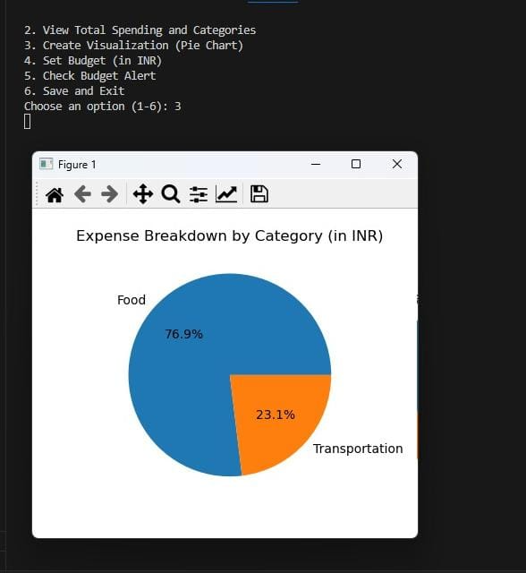
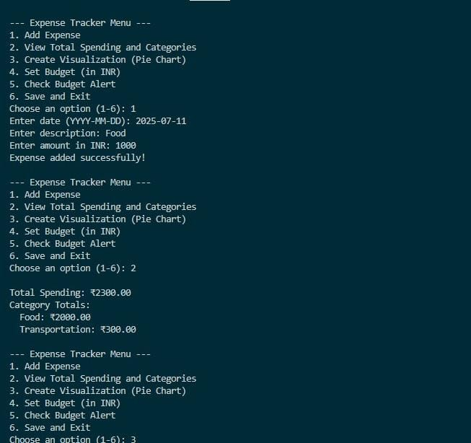

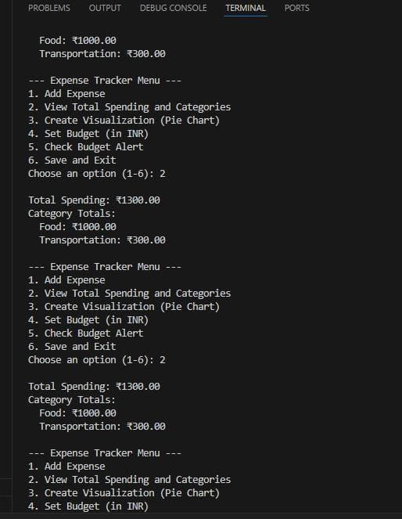

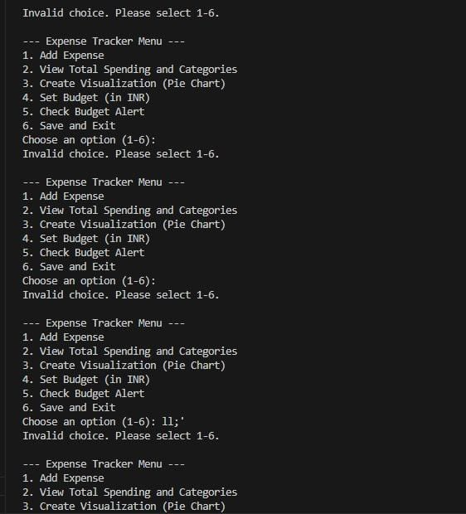

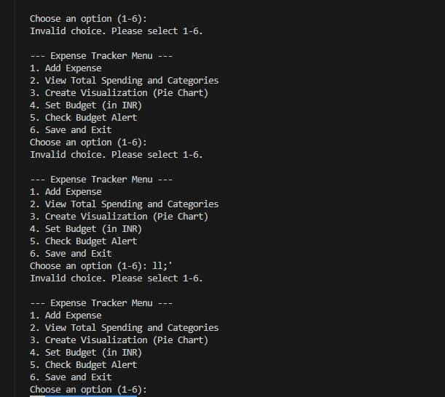s

Challenges Faced

- Designing an accurate categorization logic
- Handling missing or incomplete CSV files
- Ensuring proper datetime conversion for different formats
- Maintaining clean DataFrame structure

Learnings & Key Takeaways

- Understanding Pandas for data manipulation
- Working with CSV files and file handling
- Implementing modular Python functions
- Extracting insights from raw data
- Building a real-world mini-project from scratch

